System Comprehensive Review

User Experience Analysis & Improvement Recommendations
Document Version: 1.0
Date: June 2, 2026
Purpose: To provide clear, actionable feedback for the development team to enhance user adoption, usability, and purpose-driven design

Executive Summary
This document provides a comprehensive analysis of the P09AOCA livestock marketplace platform, focusing on user-centric design principles. The core philosophy throughout this review is:
"A user visits a website or application for a single purpose. The system should clearly show that purpose, help accomplish it quickly, and let the user move on. Anything else creates friction and reduces adoption."

Core UX Principles Applied

1. Purpose-Driven Design
Every screen should answer three questions:
- What does the user want to do?
- How can they do it quickly?
- How do they know it's done?
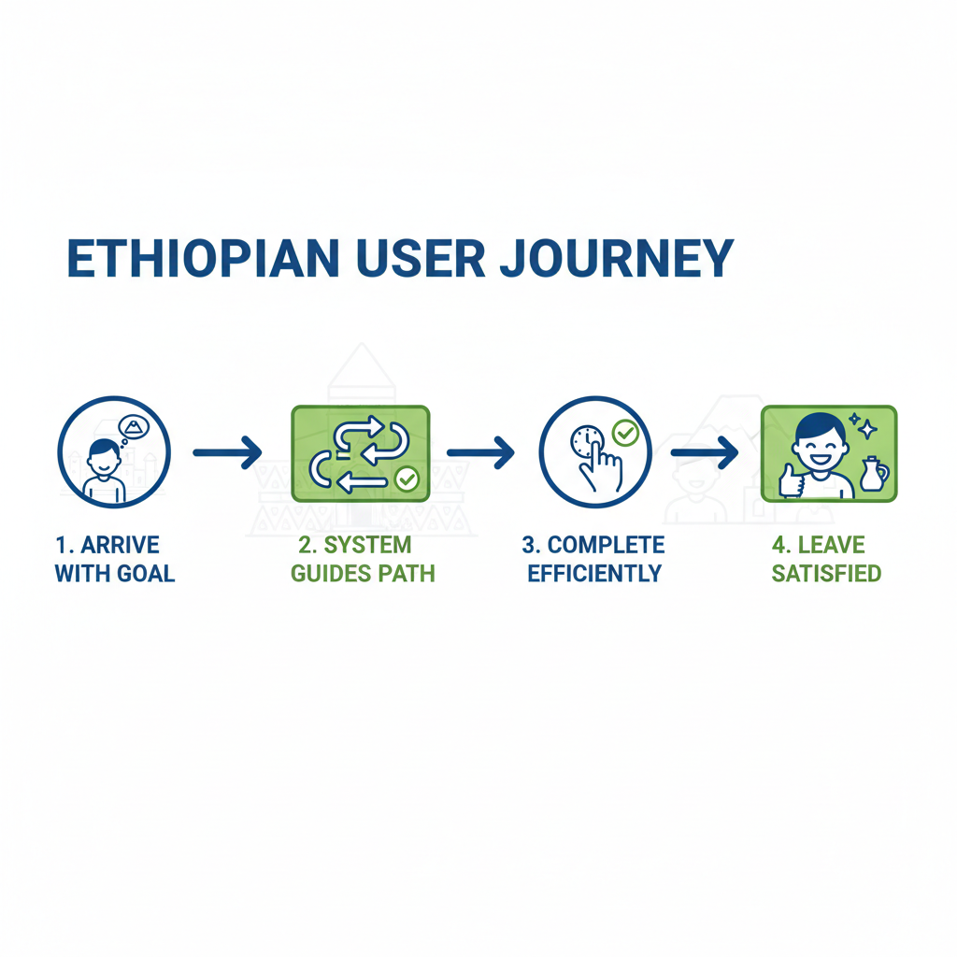
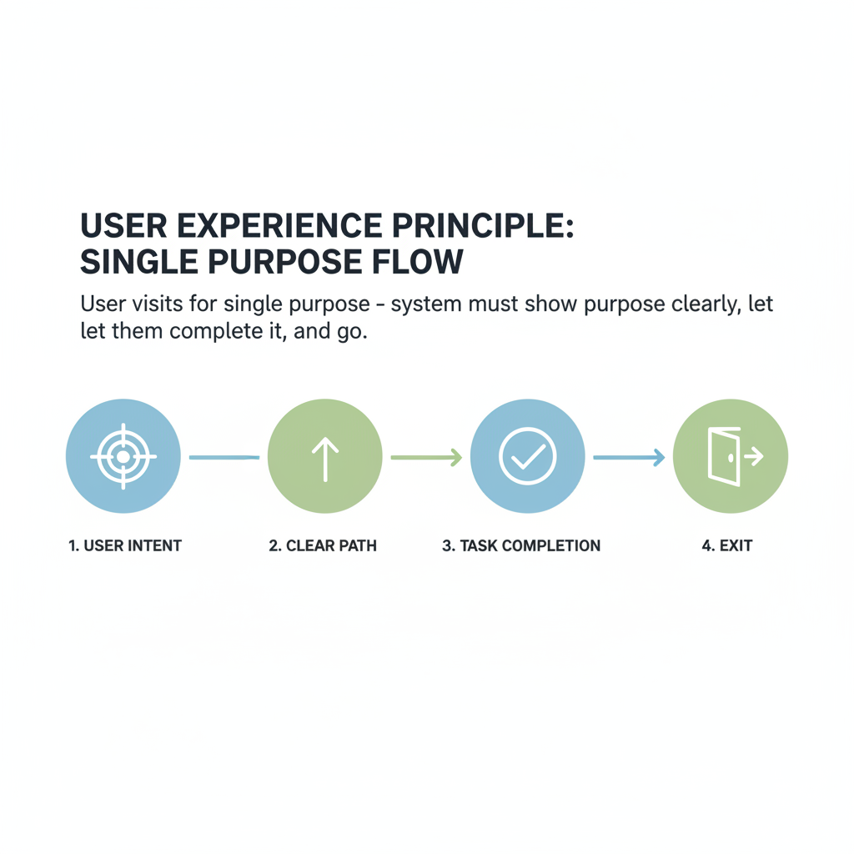

2. Cognitive Load Minimization
- Reduce decision fatigue
- Show only relevant information
- Use progressive disclosure

3. Ethiopian Context Awareness
- Local language support
- Cultural holiday integration
- Familiar payment methods
- Regional livestock categories
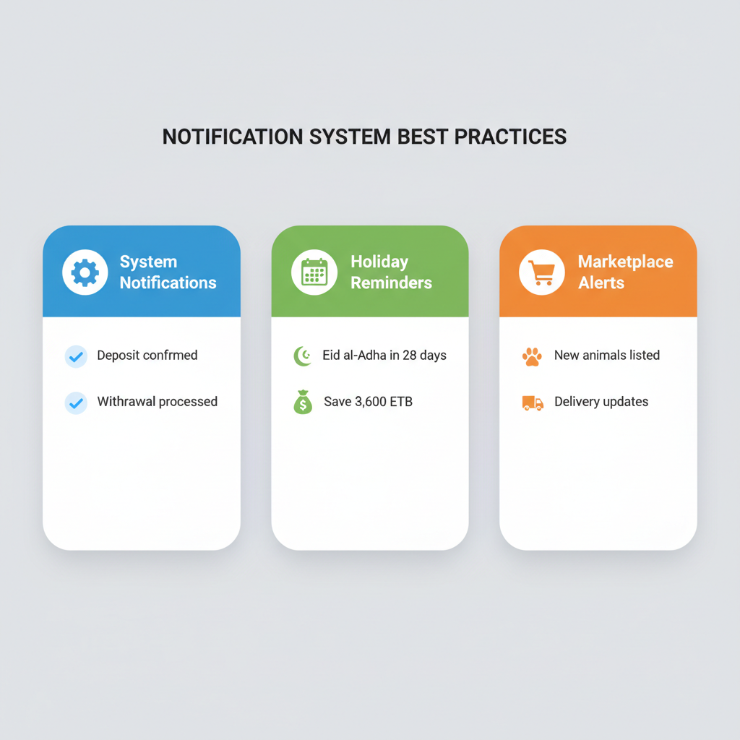

Current System Architecture
The system consists of three login sections:
- Customer Page - End users for buying livestock and managing wallets
- Marketplace - Browse and purchase animals
- Admin Page - System management and oversight

Detailed Findings & Recommendations

SECTION 1: CUSTOMER DASHBOARD

🔴 CRITICAL ISSUE #1: Fragmented Dashboard Pages
Current Problem:
- Dashboard appears to be split across multiple pages
- Users must navigate between different sections to see complete information
- Creates confusion about where to find what they need
- Violates the "single purpose" principle
Why This Matters: Users come to check their balance, make a deposit, or buy an animal. Scattering this information forces them to hunt around, creating frustration and reducing trust in the system.
Recommended Solution:
Create ONE unified dashboard with:
┌─────────────────────────────────────────────┐
│ GREETING + MEMBERSHIP STATUS │
├─────────────────────────────────────────────┤
│ WALLET OVERVIEW (single card) │
│ • Available Cash: 55,060 ETB │
│ • Locked Savings: 0 ETB │
│ • Platform Credits: 0 ETB │
│ • Quick Actions: [Deposit] [Withdraw] │
├─────────────────────────────────────────────┤
│ QUICK DEPOSIT (prominent) │
│ [100] [500] [1000] [5000] [Custom] │
├─────────────────────────────────────────────┤
│ RECENT ACTIVITY (collapsed by default) │
├─────────────────────────────────────────────┤
│ MARKETPLACE SHORTCUT │
│ "Buy Sheep, Goats, Cattle →" │
└─────────────────────────────────────────────┘
Technical Implementation:
- Consolidate all dashboard views into a single component
- Use expandable/collapsible sections for detailed views
- Implement lazy loading for transaction history
- Add caching to improve page load time
Priority: 🔴 HIGH - This is foundational to user experience

🔴 CRITICAL ISSUE #2: Missing Withdrawal Function
Current Problem:
- Dashboard shows deposit function but NO withdrawal function
- Users can put money in but can't see how to get it out
- Creates trust barrier - users worry about their funds
Why This Matters: This is a fundamental trust issue. Users need to know they can access their money. The absence of a visible withdrawal option makes the system feel like a "trap."
Psychological Impact:
- Users may deposit less (fear of not getting it back)
- Reduces platform credibility
- Creates hesitation before any transaction
Recommended Solution:
WALLET HUB - Complete View:
┌───────────────────────────────────────────┐
│ YOUR WALLET │
│ Balance: 55,060 ETB │
│ │
│ [💰 DEPOSIT] [💸 WITHDRAW] │
│ │
│ Account: FID-2024-893421 │
│ Member: Bronze │
└───────────────────────────────────────────┘
Withdrawal Flow:
- User clicks "Withdraw"
- Modal appears: "How much do you want to withdraw?"
- User enters amount or selects shortcut
- User selects withdrawal method:
  - Bank Transfer (CBE, Awash, etc.)
  - Mobile Money (Telebirr, CBE Birr, M-PESA)
- User confirms with PIN/OTP
- System shows processing time estimate
- Notification sent when complete
Business Rules to Implement:
- Minimum withdrawal: 100 ETB
- Maximum withdrawal: User's available balance
- Processing time: 1-3 business days for bank, instant for mobile money
- Withdrawal fee: Display clearly (e.g., 1% or flat fee)
Priority: 🔴 HIGH - Critical for user trust

🟡 MEDIUM ISSUE #3: Wallet Information Clarity
Current Problem:
- Multiple wallet-related numbers shown without clear explanation
- Available Cash, Locked Savings, Platform Credits, Total Spent, Total Deposit - displayed but not clearly organized
- Users may not understand what each means
Recommended Solution:
Create a clear visual hierarchy:
┌─────────────────────────────────────────────┐
│ AVAILABLE BALANCE │
│ 55,060 ETB │
│ (Money you can spend now) │
├─────────────────────────────────────────────┤
│ SAVINGS & CREDITS │
│ ┌────────────┬────────────┐ │
│ │ Locked │ Credits │ │
│ │ 0 ETB │ 0 ETB │ │
│ │ (Holiday) │ (Rewards) │ │
│ └────────────┴────────────┘ │
├─────────────────────────────────────────────┤
│ STATISTICS (Expandable) │
│ Total Deposited: 53,000 ETB │
│ Total Spent: 13,440 ETB │
│ Savings Rate: 39,560 ETB │
└─────────────────────────────────────────────┘
Implementation Notes:
- Use tooltips or info icons for each category
- Color code: Green for available, Orange for locked, Blue for credits
- Show percentage changes (e.g., "↑ 12% from last month")

SECTION 2: QUICK DEPOSIT SYSTEM

🟡 MEDIUM ISSUE #4: Limited Payment Gateways
Current Problem:
- Quick deposit appears limited in payment options
- Ethiopian users have diverse payment preferences
- Not supporting popular methods creates friction
Recommended Payment Gateway Integration:
Payment Method | Type | Priority | Why
Telebirr | Mobile Money | 🔴 Critical | Most widely used in Ethiopia
CBE Birr | Mobile Money | 🔴 Critical | Commercial Bank of Ethiopia - large user base
M-PESA | Mobile Money | 🟡 High | Popular for cross-border
Awash Bank | Bank Transfer | 🟡 High | Major private bank
CBE | Bank Transfer | 🟡 High | Largest bank in Ethiopia
Dashen Bank | Bank Transfer | 🟢 Medium | Growing user base
Abyssinia Bank | Bank Transfer | 🟢 Medium | Regional presence
Implementation Priority:
- Phase 1: Telebirr, CBE Birr (immediate)
- Phase 2: Major banks (within 2 months)
- Phase 3: Additional mobile money services

🟢 QUICK WIN #5: Shortcut Deposit Amounts
Current Observation: Good idea to add shortcuts, but amounts need optimization.
Recommended Shortcut Amounts:
┌─────────────────────────────────────────┐
│ QUICK DEPOSIT │
│ Choose amount or enter custom: │
│ │
│ [100 ETB] [500 ETB] [1,000 ETB] │
│ [5,000 ETB] [10,000 ETB] │
│ │
│ Or enter custom amount: │
│ [_____________] ETB │
│ │
│ Payment Method: │
│ [Telebirr ▼] │
│ │
│ [DEPOSIT NOW] │
└─────────────────────────────────────────┘
Why These Amounts:
- 100 ETB - Low barrier for first-time users
- 500 ETB - Common weekly savings
- 1,000 ETB - Standard deposit for regular users
- 5,000 ETB - Holiday preparation
- 10,000 ETB - Large purchase preparation
Cultural Consideration: Adjust amounts based on:
- Upcoming holidays (Eid al-Adha, Genna, Fasika)
- Average livestock prices
- User behavior data (analyze most common deposits)

SECTION 3: MARKETPLACE & LIVESTOCK

🟡 MEDIUM ISSUE #6: Livestock Category References
Current Problem:
- Sheep, goat, and cattle names should reference actual Ethiopian categories
- Users need familiar, locally-recognized breed names
- Builds trust and helps informed purchasing decisions
Ethiopian Livestock Categories - Reference Guide:
SHEEP (በግዕ - Beg):
Local Name | Amharic | Region | Avg Weight | Typical Price Range
Menz | መንዝ | Central Highland | 25-35 kg | 6,000-9,000 ETB
Horro | ሆሮ | Western Ethiopia | 30-40 kg | 7,000-10,000 ETB
Somali | ሶማሊ | Eastern Ethiopia | 25-30 kg | 5,000-7,500 ETB
Afar | አፋር | Afar Region | 20-28 kg | 4,500-7,000 ETB
Washera | ዋሸራ | Western Gojjam | 25-32 kg | 5,500-8,000 ETB
GOAT (ፍየት - Fiyet):
Local Name | Amharic | Region | Avg Weight | Typical Price Range
Somali | ሶማሊ | Eastern Ethiopia | 20-30 kg | 4,000-7,000 ETB
Afar | አፋር | Afar Region | 18-25 kg | 3,500-6,000 ETB
Central Highland | የመካከለኛ ከፍታ | Central | 20-28 kg | 4,000-6,500 ETB
Begit | በጊት | Western | 22-30 kg | 4,500-7,000 ETB
CATTLE (ላም - Lam):
Local Name | Amharic | Region | Purpose | Typical Price Range
Boran | ቦራን | Southern Ethiopia | Dual-purpose | 35,000-60,000 ETB
Fogera | ፎገራ | Amhara Region | Dual-purpose | 30,000-55,000 ETB
Horro | ሆሮ | Western Ethiopia | Dual-purpose | 32,000-58,000 ETB
Sheko | ሸኮ | Southern | Dairy | 40,000-70,000 ETB
Arsi | አርሲ | Oromia | Dual-purpose | 30,000-50,000 ETB
Implementation in Marketplace:
Category: SHEEP
├── Menz Sheep (መንዝ በግዕ)
│ ├── Weight: 35kg
│ ├── Source: Central Highland, Menz area
│ └── Price: 6,500 ETB
├── Horro Sheep (ሆሮ በግዕ)
│ ├── Weight: 48kg
│ ├── Source: Western Ethiopia
│ └── Price: 9,800 ETB
└── Somali Sheep (ሶማሊ በግዕ)
└── ...
Why This Matters:
- Users recognize and trust local breed names
- Helps verify authenticity of animals
- Supports informed purchasing decisions
- Connects to cultural knowledge

🔴 CRITICAL ISSUE #7: Order Cancellation Logic
Current Problem:
- "When the item delivers the cancel order should be immediately erased"
- This is confusing - cancellation should not happen after delivery
- Need clear order status flow
Recommended Order Status Flow:
ORDER LIFECYCLE:

[PLACED] → [CONFIRMED] → [IN TRANSIT] → [DELIVERED] → [COMPLETED]
↓ ↓ ↓ ↓
[CANCELLED] [CANCELLED] [CANCELLED] (NO CANCELLATION)
↓ ↓ ↓
[REFUNDED] [REFUNDED] [PARTIAL REFUND]
Clear Rules:
Status | Can Cancel? | What Happens
Placed | ✅ Yes | Immediate cancellation, full refund
Confirmed | ✅ Yes | Cancellation within 2 hours, full refund
In Transit | ⚠️ Conditional | Contact support, depends on driver location
Delivered | ❌ No | Order is complete, no cancellation
Completed | ❌ No | Transaction finalized
UI Implementation:
┌─────────────────────────────────────────────┐
│ ORDER #12345 │
│ Status: IN TRANSIT │
│ Driver: Ato Bekele - 0911234567 │
│ ETA: 30 minutes │
│ │
│ [TRACK ORDER] [❌ CANCEL] │
│ │
│ ⚠️ Cancellation may incur 10% fee │
└─────────────────────────────────────────────┘

After Delivery:
┌─────────────────────────────────────────────┐
│ ORDER #12345 │
│ Status: DELIVERED ✓ │
│ Delivered: June 2, 2026 at 10:30 AM │
│ │
│ [RATE SELLER] [REPORT ISSUE] │
│ │
│ Leave a review for this transaction │
└─────────────────────────────────────────────┘
Automatic Actions:
- When marked "Delivered": Remove from active orders
- Move to "Order History"
- Prompt for review
- Remove cancellation option
- Update transaction history

SECTION 4: NOTIFICATION SYSTEM

🟡 MEDIUM ISSUE #8: Notification Naming Convention
Current Observation: Need consistent naming convention for notifications.
Recommended Notification Categories:
NOTIFICATION TYPES:

1. SYSTEM NOTIFICATIONS (⚙️)
- "System Notification: Deposit Confirmed"
- "System Notification: Withdrawal Processed"
- "System Notification: Password Changed"

2. WALLET NOTIFICATIONS (💰)
- "Wallet: +1,000 ETB received from Family-Meron"
- "Wallet: 500 ETB locked for Eid savings"
- "Wallet: Withdrawal of 2,000 ETB processing"

3. HOLIDAY REMINDERS (📅)
- "Eid al-Adha Reminder: Only 28 days left!"
- "Holiday Goal: You have saved 3,600 ETB of 5,000 ETB goal"
- "Genna (Christmas): 6 months to save"

4. MARKETPLACE ALERTS (🛒)
- "Marketplace: 5 new sheep listed near you"
- "Marketplace: Your order #12345 is out for delivery"
- "Marketplace: Holiday season discount - 10% off!"

5. SECURITY ALERTS (🔒)
- "Security: New login from Addis Ababa"
- "Security: PIN changed successfully"
- "Security: Verify your phone number"
Notification Display Rules:
┌─────────────────────────────────────────────┐
│ NOTIFICATIONS [Mark all read] │
├─────────────────────────────────────────────┤
│ ⚙️ System Notification │
│ Deposit Confirmed │
│ Your deposit of 1,000 ETB has been... │
│ 2 minutes ago │
├─────────────────────────────────────────────┤
│ Marketplace Alert │
│ Order Delivered! │
│ Your Menz sheep has been delivered... │
│ 1 hour ago │
├─────────────────────────────────────────────┤
│ Holiday Reminder │
│ Eid al-Adha in 28 days │
│ Save 3,600 ETB more to reach your goal │
│ 3 hours ago │
└─────────────────────────────────────────────┘
Implementation Notes:
- Prefix all notifications with category name
- Use consistent icons
- Allow users to filter by category
- Enable/disable categories in settings
- Badge count shows unread notifications

SECTION 5: HOLIDAY PLANNER

🟢 GOOD FEATURE #9: Holiday Planning
Current Observation: Good concept - helping users save for Ethiopian holidays.
Ethiopian Holiday Calendar for Planning:
Holiday | Amharic | Date (2026-2027) | Suggested Savings Goal
Eid al-Adha | ዒድ አል-አድሃ | June 16, 2026 | 5,000-10,000 ETB
Ethiopian New Year | እንቁጣጣሽ | September 10, 2026 | 2,000-5,000 ETB
Genna (Christmas) | ገና | January 6, 2027 | 3,000-8,000 ETB
Timkat (Epiphany) | ጥምቀት | January 18, 2027 | 2,500-5,000 ETB
Fasika (Easter) | ፋሲካ | April 19, 2027 | 4,000-10,000 ETB
Enhanced Holiday Planner UI:
┌─────────────────────────────────────────────┐
│ HOLIDAY PLANNER │
│ Prepare for upcoming celebrations │
├─────────────────────────────────────────────┤
│ Eid al-Adha (ዒድ አል-አድሃ) │
│ June 16, 2026 - 14 days away │
│ │
│ Goal: 5,000 ETB │
│ Saved: 3,600 ETB (72%) │
│ [████████████░░░░░░░░] 72% │
│ │
│ Tip: Save 100 ETB/day to reach goal │
│ [+ ADD TO SAVINGS] │
├─────────────────────────────────────────────┤
│ Ethiopian New Year (እንቁጣጣሽ) │
│ September 10, 2026 - 100 days away │
│ │
│ Goal: 3,000 ETB │
│ Saved: 500 ETB (17%) │
│ [████░░░░░░░░░░░░░░░░] 17% │
└─────────────────────────────────────────────┘
Automatic Features:
- Calculate daily/weekly savings needed
- Send reminders at milestones (50%, 75%, 90%)
- Lock savings option (prevent early withdrawal)
- Suggest amounts based on household size

SECTION 6: USER SETTINGS & PROFILE

🟢 LOW PRIORITY #10: Profile Completeness
Current State: User profile shows basic information.
Enhancement Suggestions:
- Add profile completeness indicator
- Prompt for verification (phone, ID)
- Multi-language support (Amharic, Oromo, Tigrinya, English)
┌─────────────────────────────────────────────┐
│ PROFILE │
│ Yohannes Berhe │
│ FID-2024-893421 │
│ Bronze Member │
│ │
│ Profile Completeness: 75% │
│ [███████████████░░░░░] 75% │
│ │
│ ✓ Full Name │
│ ✓ Phone Number (Verified) │
│ ✓ Address │
│ ✗ ID Verification │
│ ✗ Profile Photo │
│ │
│ [COMPLETE PROFILE] │
└─────────────────────────────────────────────┘
Why Profile Completeness Matters:
- Increases trust for transactions
- Required for higher withdrawal limits
- Better security verification

SECTION 7: ADMIN DASHBOARD

🟡 MEDIUM PRIORITY: Admin Overview
Current Admin Dashboard Shows:
- Total Deposits: 190,200 ETB
- Total Spent: 74,140 ETB
- 8 users (visible)
- Quick Actions: Broadcast Notification, Add Holiday, Generate Report
Recommended Admin Dashboard Enhancements:
┌─────────────────────────────────────────────────────────────┐
│ ADMIN DASHBOARD Admin User │
├─────────────────────────────────────────────────────────────┤
│ PLATFORM METRICS (Last 30 Days) │
│ ┌──────────────┬──────────────┬──────────────┐ │
│ │ Users │ Transactions │ Volume │ │
│ │ 156 (+12%) │ 847 (+8%) │ 1.2M ETB │ │
│ └──────────────┴──────────────┴──────────────┘ │
│ │
│ FINANCIAL OVERVIEW │
│ ┌──────────────┬──────────────┬──────────────┐ │
│ │ Deposits │ Withdrawals │ Platform Fee │ │
│ │ 190,200 ETB │ 45,600 ETB │ 12,340 ETB │ │
│ └──────────────┴──────────────┴──────────────┘ │
│ │
│ MARKETPLACE ACTIVITY │
│ • Sheep Listed: 34 | Sold: 21 │
│ • Goats Listed: 18 | Sold: 12 │
│ • Cattle Listed: 8 | Sold: 3 │
│ │
│ UPCOMING HOLIDAYS │
│ • Eid al-Adha (June 16) - 14 days │
│ • Enkutatash (Sept 10) - 100 days │
│ │
│ ⚠️ PENDING APPROVALS │
│ • 3 Withdrawal Requests │
│ • 2 New Seller Applications │
│ │
│ QUICK ACTIONS │
│ [Broadcast] [Add Holiday] [Generate Report] [User Mgmt] │
└─────────────────────────────────────────────────────────────┘
Admin Features Needed:
- User Management (approve, suspend, verify)
- Transaction Monitoring (flag suspicious activity)
- Withdrawal Approval Queue
- Seller Verification
- Report Generation (PDF, CSV exports)
- Notification Broadcasting
- Holiday Configuration
- Payment Gateway Configuration

Priority Implementation Matrix

Phase 1: Critical (Week 1-2)
Issue | Priority | Effort | Impact
Add Withdrawal Function | 🔴 Critical | Medium | HIGH
Consolidate Dashboard | 🔴 Critical | Medium | HIGH
Order Status Flow | 🔴 Critical | Low | HIGH

Phase 2: High Priority (Week 3-4)
Issue | Priority | Effort | Impact
Payment Gateway Integration | 🟡 High | High | HIGH
Notification System | 🟡 Medium | Medium | MEDIUM
Livestock Categories | 🟡 Medium | Low | MEDIUM

Phase 3: Medium Priority (Month 2)
Issue | Priority | Effort | Impact
Shortcut Deposit Amounts | 🟢 Low | Low | MEDIUM
Holiday Planner Enhancement | 🟢 Low | Medium | MEDIUM
Profile Completeness | 🟢 Low | Low | LOW

User Adoption Principles

Key Takeaways for Development Team
- Single Purpose Focus
  - Every screen should have ONE primary action
  - Secondary actions should be clearly subordinate
  - Users should never wonder "what do I do here?"
- Trust Building
  - Show withdrawal options prominently
  - Display transaction history clearly
  - Provide order tracking in real-time
- Ethiopian Context
  - Use local breed names and references
  - Support local payment methods
  - Integrate Ethiopian holidays
  - Consider local language support
- Progressive Disclosure
  - Show essential information first
  - Hide details until needed
  - Use expandable sections
- Feedback Loops
  - Confirm every action immediately
  - Show processing status
  - Notify on completion

Testing Recommendations

User Testing Scenarios
Scenario 1: New User Registration
- User creates account
- User makes first deposit
- User browses marketplace
- User purchases first animal
Scenario 2: Returning User
- User checks balance
- User withdraws funds
- User checks order history
- User saves for holiday
Scenario 3: Holiday Preparation
- User sets holiday savings goal
- User makes regular deposits
- User receives reminder notifications
- User achieves goal

Success Metrics
Metric | Target | Measurement
Task Completion Rate | > 85% | % of users completing primary task
Time to Complete Task | < 2 minutes | Average time for key actions
User Satisfaction | > 4.0/5.0 | Post-transaction survey
Withdrawal Success Rate | > 95% | Completed withdrawals / requests
Order Completion Rate | > 90% | Delivered orders / placed orders

Conclusion
The P09AOCA platform has strong foundations but requires focused improvements to maximize user adoption. The key is to remember:
Users don't want to explore your system—they want to accomplish a task and leave. Make that task as obvious and simple as possible.
Every feature, every button, every notification should be evaluated against this principle: Does this help the user accomplish their purpose, or does it add noise?

References & Best Practices

UX Design Principles Applied
- Nielsen's 10 Usability Heuristics
- Don Norman's User-Centered Design
- Material Design Guidelines
- iOS Human Interface Guidelines

Ethiopian Financial Technology Context
- National Bank of Ethiopia mobile money regulations
- Ethiopian livestock market standards
- Cultural holiday calendars (Ethiopian Orthodox, Islamic)

Recommended Reading
- "Don't Make Me Think" by Steve Krug
- "The Design of Everyday Things" by Don Norman
- "Lean UX" by Jeff Gothelf

Document prepared for: P09AOCA Development Team
Reviewer: UX Consultant
Next Review: After Phase 1 implementation

Appendix: Quick Reference Card

For Developers - Summary of Changes
MUST DO:
- ✅ Add withdrawal button next to deposit
- ✅ Merge all dashboard pages into one
- ✅ Create clear order status workflow
- ✅ Add Telebirr and CBE Birr payment gateways
SHOULD DO:
- ✅ Implement notification categories
- ✅ Add Ethiopian livestock breed names
- ✅ Enhance holiday planner with progress bars
- ✅ Add shortcut deposit amounts
NICE TO HAVE:
- ✅ Profile completeness indicator
- ✅ Multi-language support
- ✅ Advanced admin analytics

End of Document

